Job Application Form
Harris Tweed Authority - Administrator
Closing date for applications – 12pm, Wed 11th October 2023

Confidential

JOB APPLICATION | Administrator
The Harris Tweed Authority, The Town Hall, 2 Cromwell Street, Stornoway, Isle of Lewis, HS1 2DB

Please complete this form in BLOCK CAPITALS in BLACK INK or ELECTRONICALLY.
A The Post
Title | Development Officer

B Personal Details
Full Name | Do you have a current and full driving licence?  YES/NO
Address and Post Code | Are you a car owner? YES/NO
Address and Post Code | E-mail
Home Phone No. | Mobile Number

C Education
In order of attendance
School/College/University | Dates |  | Subject | Level and standard attained
School/College/University | From | To | Subject | Level and standard attained

D Other Qualifications

If you are related to a current employee or Board member of the Harris Tweed Authority, please give details below. This will not affect your application in any way.

E Relationship
Name of Officer or Member related to you. | Nature of Relationship

Please indicate the extent of your ability to speak, write and read Gàidhlig. Place a cross against the category which you think best describes you.

F Gàidhlig Ability
Native Speakers | Learners | No Knowledge
Speaking | Speaking | Speaking
Writing | Writing | Writing
Reading | Reading | Reading

G Convictions
If you have had any convictions please give details.

I Details of your current post
Name and address of current employer |  | Date of commencement of this employment:
Current Salary:

Salary Expectation:

 |  | What period of notice would you require to give your present employer?
Current Post Title:
Duties of the post:

J Employment History
This information should cover the period over the past ten years.
Dates |  | Name and address of employer | Post Held and Duties | Salary (£)
From | To | Name and address of employer | Post Held and Duties | Salary (£)
(please continue on an additional sheet if required)

The following Section should be used to explain why you think you have the necessary skills, experience and ability to undertake the duties of the post. Before you complete this Section please study carefully the Job Description to ensure that you possess the specific skills and experience identified for the post. Please give examples to demonstrate that you have the necessary qualities for this post. You may also provide a CV to supplement the information provided in this form.

K Summary of your skills, experience and ability to meet the requirements of the post.

L Hobbies and Recreational Activities

M Health
Do you have, or have you had any illness or health problems which could affect your ability to undertake the duties of this post? If so, please give details (This information will be treated IN STRICT CONFIDENCE).

N Disability
If you have any disability you may wish to indicate, please give details. (This information will be treated in STRICT CONFIDENCE).

If you need any special access arrangements (ie disabled access) to enable you to attend an interview, please specify.

P References
Please give details of who should be able to provide references for you. One of these should be your current or most recent employer.
Name:  Address: | Name:  Address:
Contact Details – Telephone: | Contact Details – Telephone:
Post Held: | Post Held:
Relationship with applicant: | Relationship with Applicant:
Do we have your permission to contact your referees prior to interview? YES/NO

Q Declaration
I confirm that the information contained in this application form is true in every respect.

Signature ............................................................................. Date ................................

If appointed, information provided in this application form and found subsequently to be untrue, will lead to termination of contract. The Authority operates a probation period for all new employees.

THE COMPLETED APPLICATION FORM SHOULD BE EMAILED TO
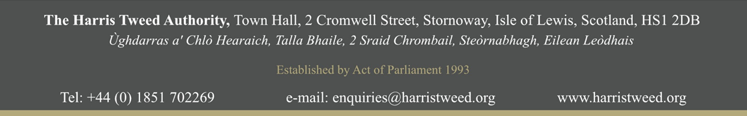
kristina@harristweed.org not later than 12 noon on Wed 11th October 2023.

